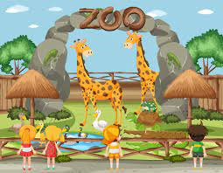
Year 3 - Dudley Zoo and Castle visit - Friday 28th June 2024

Dear Parents/Carers,

Our Year 3 visit to Dudley Zoo and Castle takes place on Friday 28th June. Both the staff and children are looking forward to this exciting educational day out! Children will get chance to be part of a fun-filled day, encountering a range of animals from around the world, making memories with their peers. Please see below for some essential reminders about the day:

- Times – Normal drop-off time of 8:40am. Normal collection time of 3:15pm (traffic permitting). Upon their return, please collect your child from the usual position on the main playground.
- Clothing – Normal school uniform, including school shoes/black trainers and a suitable coat. Sun hat/cap if the weather is hot.
- Food and drink – Please provide a packed lunch for your child to carry in their own bag and a water bottle suitable to be carried in your child’s bag. If your child is entitled to a free school meal (packed lunch), please indicate their preference on the slip below. A packed lunch will only be provided if the slip is returned
- Sun cream – If required, please apply sun cream prior to coming into school. Please do not send sun cream with your child.
- Bag – Suitable for your child to wear, in order to carry their own packed lunch and water bottle, even if the packed lunch has been ordered from school.
- No money – Please do not send any money with your child as we will not have time to visit the shop. A goodie bag has been ordered for your child which is included in the total cost.
- Medication –If your child requires medication to be taken during this visit, please speak to staff in the main reception to organise completion of the relevant paper form(s) for this.

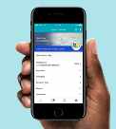
In order for your child to attend this exciting day out, please make payment via the School Gateway App before Friday 5th June 2024. If any families are struggling to pay this amount, please speak to your child’s class teacher to arrange a supportive meeting to discuss this.
Yours sincerely

Miss Geinda
Year 3 Lead

Year 3 visit to Dudley Zoo Friday 28th June 2024

My child is entitled to a free school meal (packed lunch). Their sandwich preference is:

Ham Cheese

Child’s Name ……………………………………………………………….. Class ………………….

